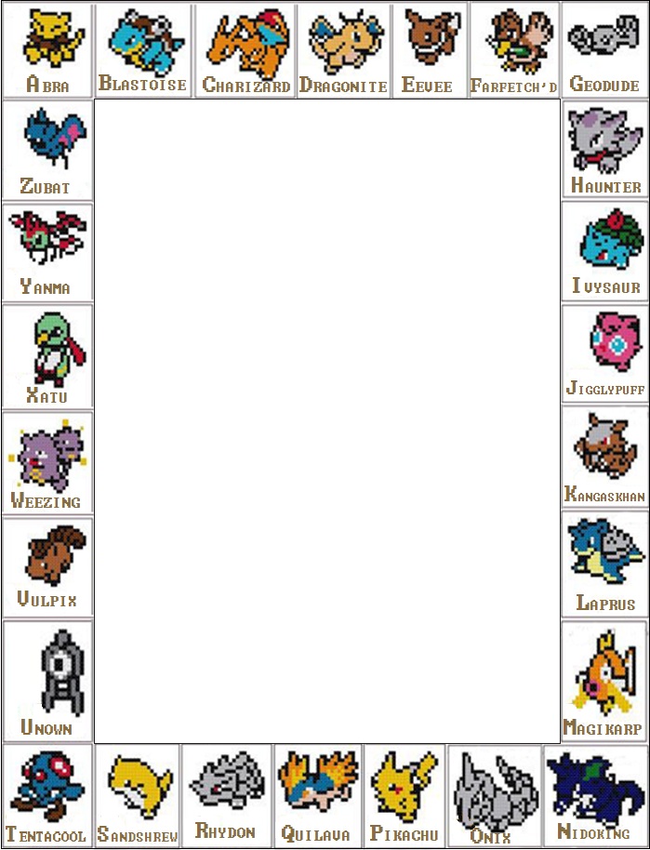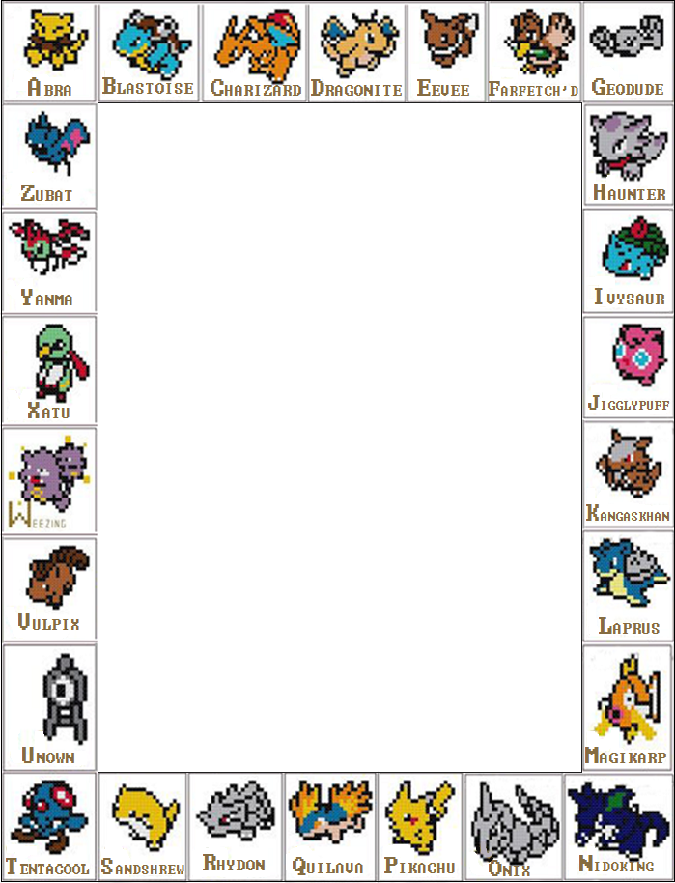

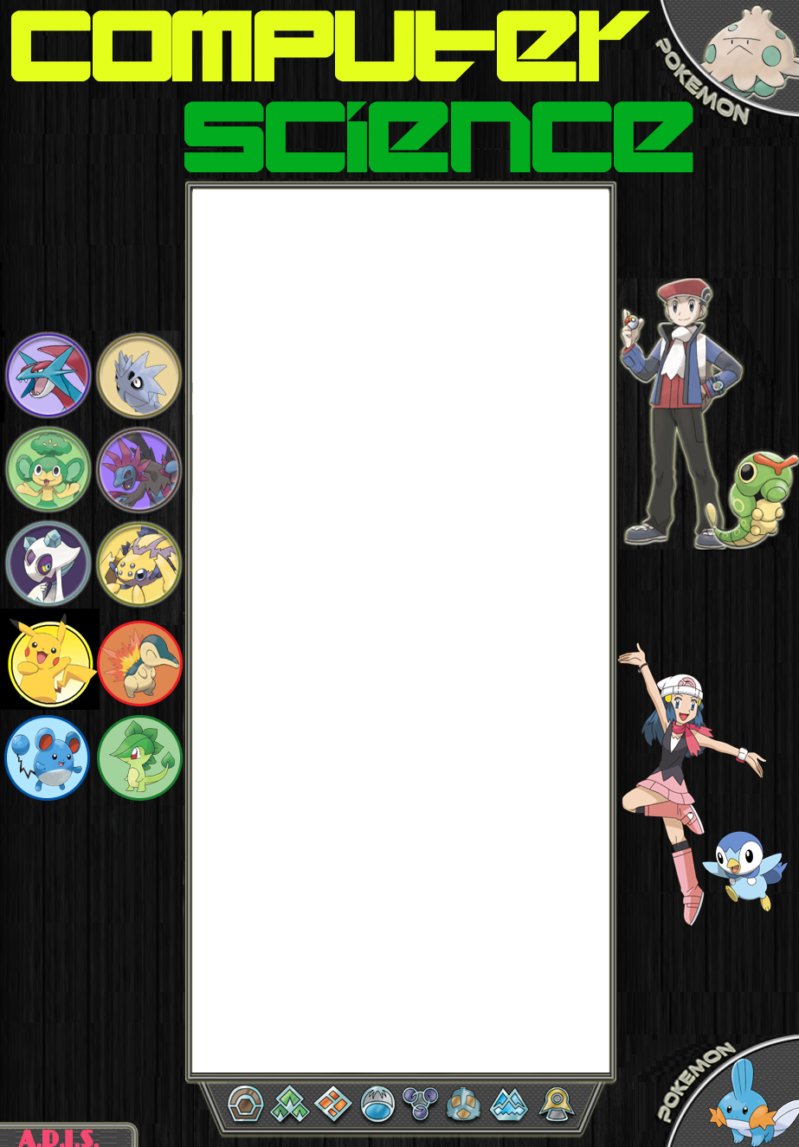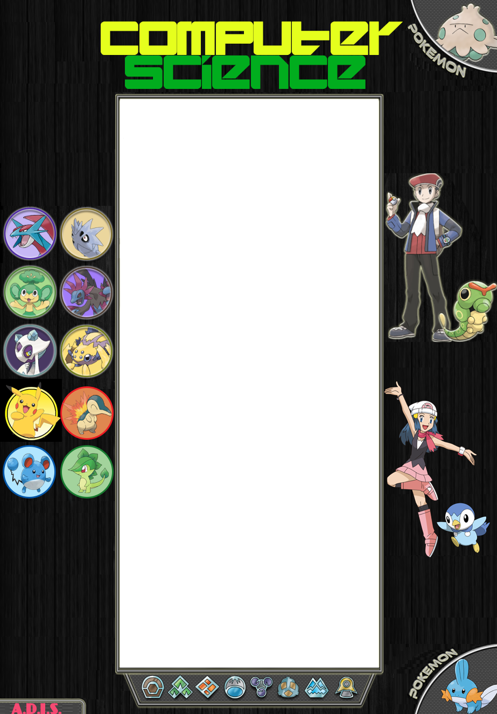

**2015-2016**

**Pokémon**

Programmed using C++

By- **Amrut Prabhu**

12 B

Abu Dhabi

Indian School



**Acknowledgement**

I would like to express my heartfelt and sincere gratitude towards my computer science teacher, Mrs. Lekshmi Sunil, for giving me an opportunity to make this project and for her valuable guidance and undying support.

I also want to take this opportunity to thank my family members and friends for their advice and support throughout the course of development of this project.



**Table of Contents**

**Acknowledgment**  **1**

**Table of Contents**  **2**

**Aim**  **3**

**Problem Definition**  **4**

**Technical Documentation**  **5**

Header Files 5

Data Structures 5

User Defined Functions 6

**Technical Specifications** **8**

Hardware Specifications 8

Software Specifications 8

**Flowchart**  **9**

**Source Code** **10**

**Sample Output** **44**

**Result**  **47**

**Merits and Demerits**  **48**

**Bibliography**  **49**

**Aim**

* To create a program to simulate the classic “Pokémon” game using C++ programming language.
* To incorporate classes and file handling in the said program.

**Problem Definition**

After a stressful day, all you want to do is just forget all you troubles, lay back on the couch, playing a game. This program allows you to do exactly that. It makes it possible for you to relax in the comfort of your own home instead of going out to an arcade.

The “Pokémon” game features a simplistic interface, easy controls, a lag-free experience and can be enjoyed by people of all ages. It provides the user with an opportunity to break away from reality into the wonderful world of Pokémon and adventure. The game is geared towards casual gamers.

**Technical Documentation**

**Header Files**

* iostream.h
* fstream.h
* SFML/Graphics.hpp
* SFML/Audio.hpp
* string.h
* windows.h
* conio.h
* math.h
* process.h

**Data Structures**

* struct attacks : It is a structure which provides a utility to store the name, location of the image file, power and type of the attack.
* struct info : It is a struture in which the details of the Pokémon is stored. The details include name, height, weight, category, attack strength, defense strength and the moves which can be used by the Pokémon, along with their descriptions.
* class character : It includes public data members such as locations of the image files of the character and the position of the character on the map. It also consists of member ****functions for resetting the position of the character and for copying the image locations to the variables.
* class pokemon : It includes attack strength, defense strength and speed of the Pokémon as private data members. The name, health and position of the Pokémon are public data members along with the locations of the image files of the Pokémon and an array of structure “attacks”. Accessor and Mutator functions are present in the public section of the class, so as to provide access to the private members.

**User Defined Functions**

* **void intro1():** It is a function used for bringing up the first opening animation.
* **void intro2():** It is a function used for bringing up the second opening animation.
* **void title():** It is a function used for displaying title screen.
* **void disp(int):** It is a function used for displaying “How to Play” and “About” screens.
* **void pokedex():** It is a function used for displaying the available Pokémon in the Pokédex, which is essentially an information hub.
* **void pokeinfo(int):** It is a function used for displaying information about the Pokémon chosen in pokedex() function.
* **void choosech**(): It is a function used for opening the Character Select window.
* **void choosepoke():** It is a function used for opening the window to choose the Pokémon.
* **void game():** It is a function used to start the main game and bring up the map on which the character moves in search of wild Pokémon.
* **void fight(pokemon&,pokemon&):** It is a function used for starting the battle with the wild Pokémon and it brings up the battle screen.
* **void attackfunc(pokemon&, pokemon&, int):** It is a function used for the application of the required effect, depending on the selected move.
* **void result(pokemon&, pokemon&, int):** It is a function used for bringing up the result screen.

**Technical Specifications**

**Hardware Used**

Processor: Intel Core i7-4710 HQ CPU @ 2.50 GHz

RAM: 16 GB DDR3

Graphics Card: Intel HD Graphics 4600

**Software Used**

Operating System: Windows 8.1

IDE: Microsoft Visual Studio 2013

Compiler: Microsoft C/C++ Compiler87

External Library: Simple and Fast Multimedia Library (SFML)



**Flowchart**





**Sample Output**

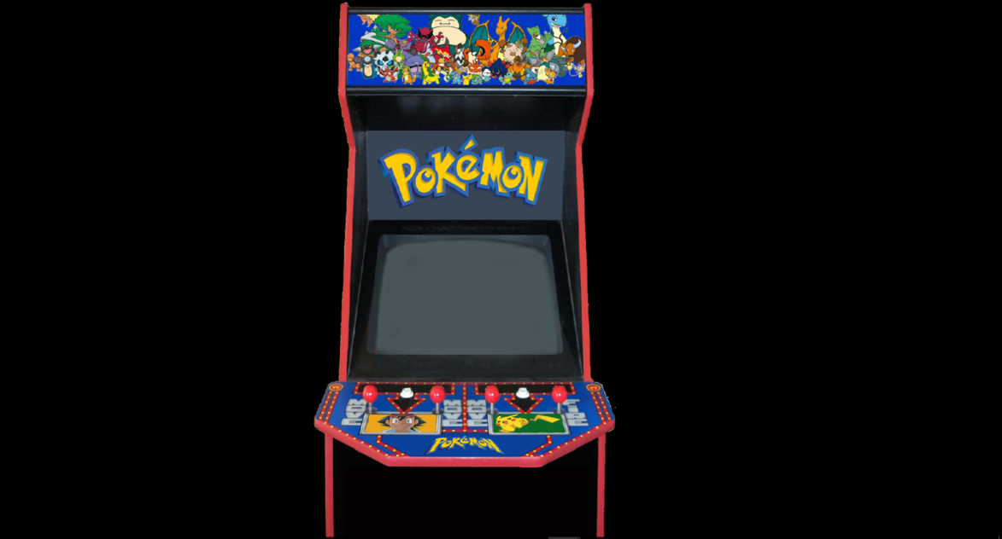

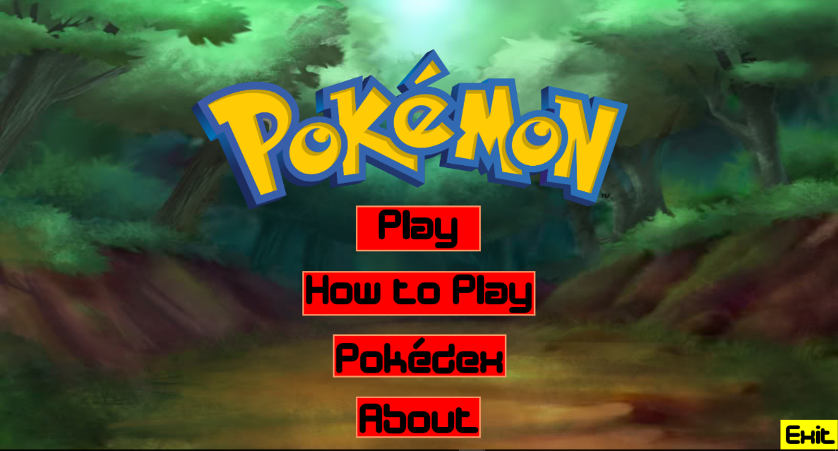

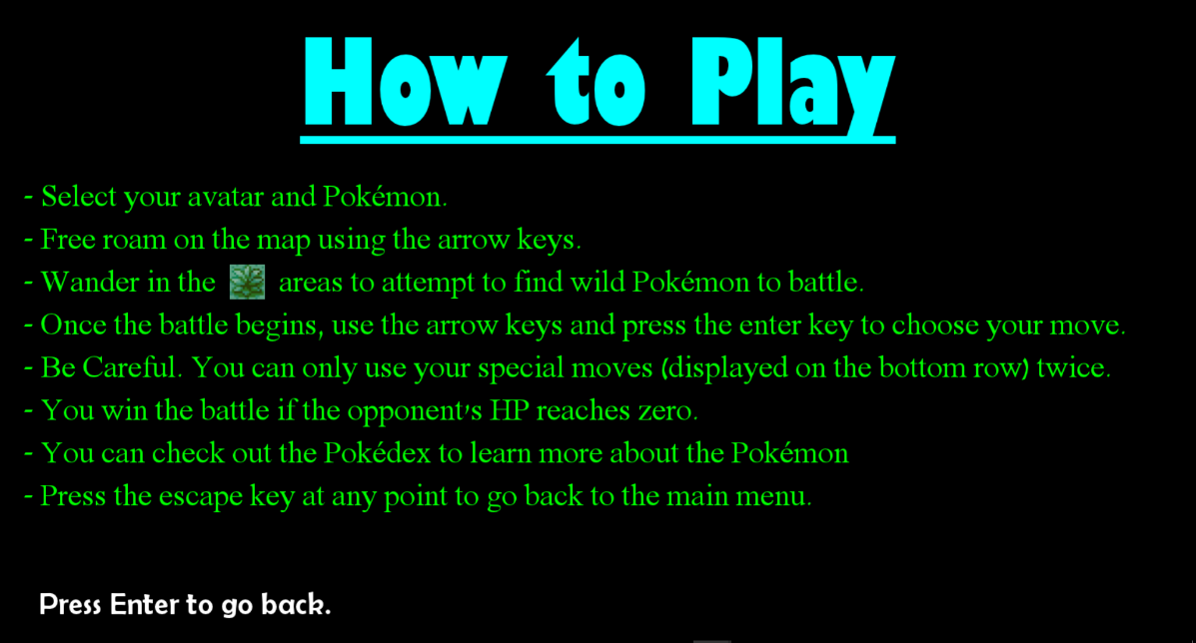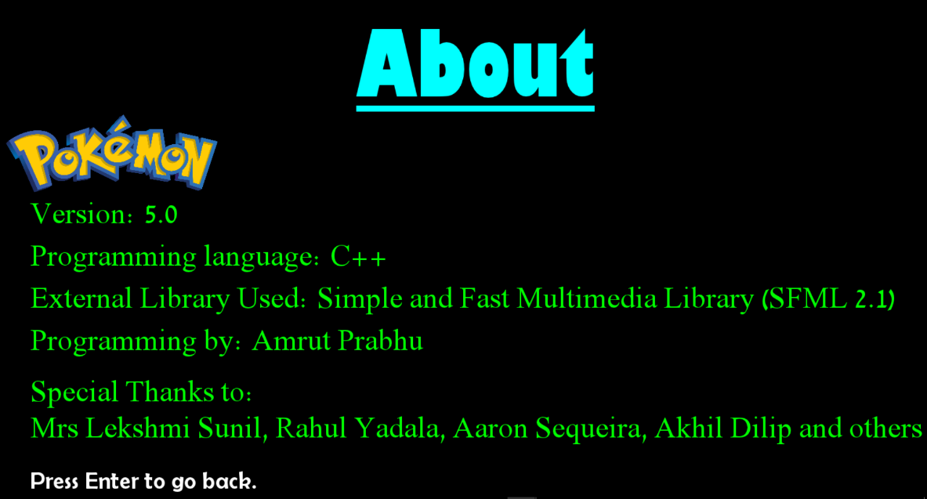

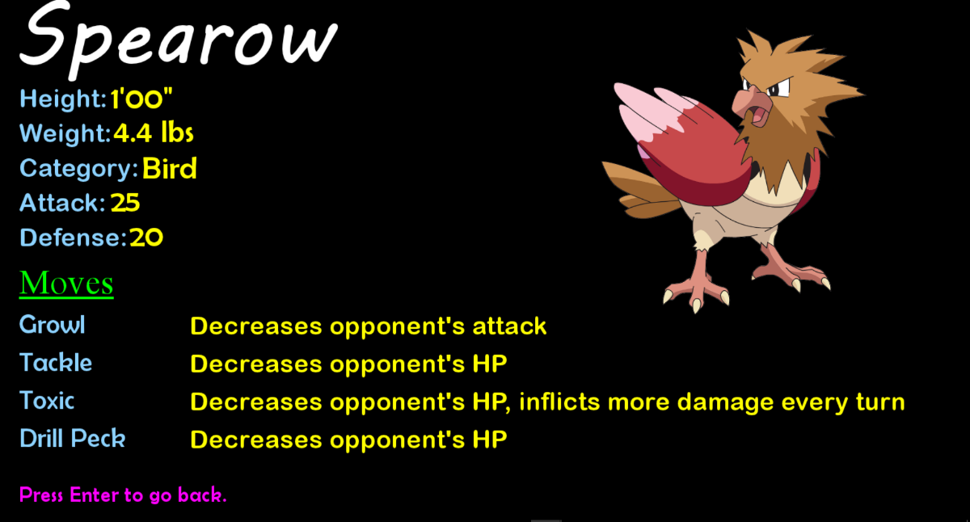

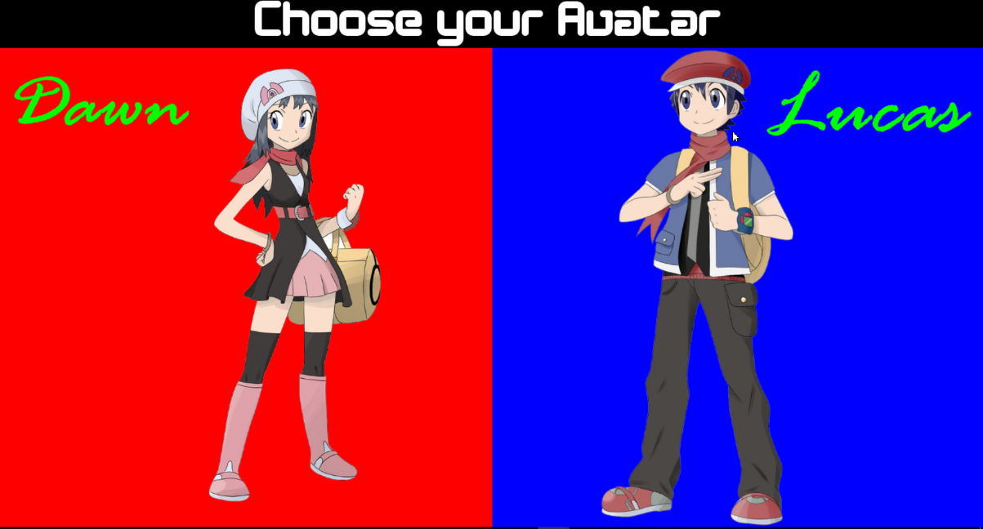

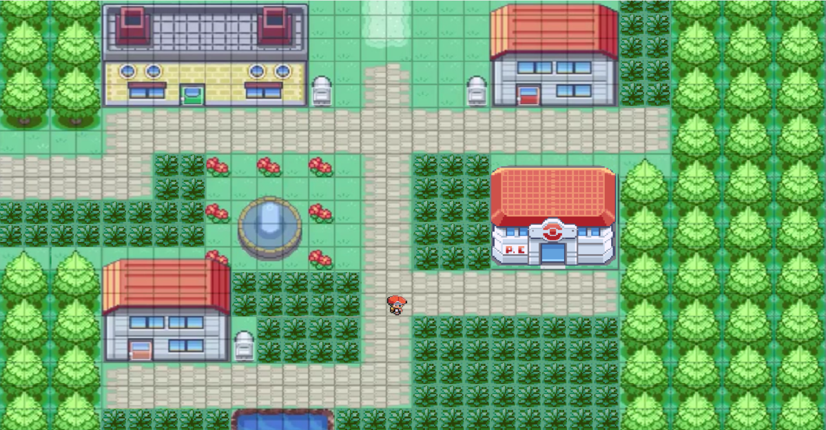



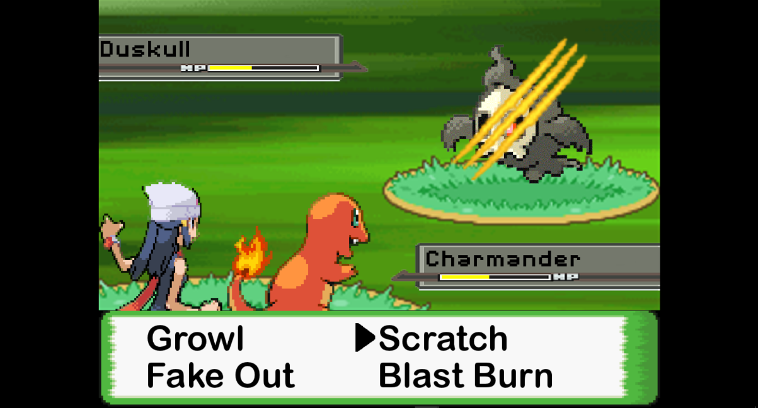





**Result**

A program simulating the classic “Pokémon” game using C++ programming language has been successfully created along with the incorporation of classes and file handling.

**Merits and Demerits**

**Merits**

* ****The program is extremely user friendly and features simple commonly used controls.
* It perfectly simulates the battles from the original “Pokémon” game and brings up visuals related to the attacks used, to give a more realistic experience.
* The game is quick paced. The user can sneak in a quick game and then go back to what they were doing.
* The game features a wiki called “Pokédex” through which the player can get information about the Pokémon in the game and plan his strategy for the battles accordingly.

**Demerits**

* There is no save feature. The players cannot begin from where they left off, once they exit the game.
* There is not much choice of characters and user Pokémon available.
* The program is not portable and is designed according to the specifications of the computer on which it was created.

**Bibliography**

* Computer Science with C++ by Sumita Arora
* SFML- www.sfml-dev.org/tutorials/2.1/
* YouTube channel: Sonar Systems-

www.youtube.com /user/sonarsystemslimited

* Stack Overflow - [www.stackoverflow.com](http://www.stackoverflow.com)
* Google Images- www.images.google.com